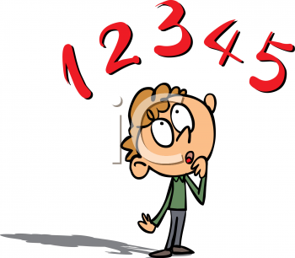
Scientific notation & Significant figures

Scientific notation:
- A shorthand way to write very small or very large numbers
- They are expressed as a multiple of 10.
- Scientific notation has the form: M x 10^{n} → where M is a number having a single non-zero digit to the left of the decimal point and n is a positive or negative exponent which represents how many times the 10 must be multiplied by itself.
- Example: 10x10x10x10 = 10⁴ OR 1/(10x10x10x10) = 10⁻⁴
- When doing operations with powers of 10, use the EXP OR □^{x} button on your calculator – DO NOT individually key in scientific numbers
- + powers = Large Numbers, and – powers = small numbers
Significant Figures:
- Accuracy is the closeness of a measurement to the true value of what is being measured precision is the reproducibility, under the same conditions of measurement
- Significant figures are those digits in a number that are known with certainty plus the first digit that is uncertain.
- All non-zero numbers are considered to be significant figures
- Zero is considered to be non-significant, except in the case it is BETWEEN two non-zero digits.
- When performing calculations, always use the maximum decimal values by saving numbers in the calculator. When writing the final answer, only use the number of significant figures of the LEAST accurate number.
